A Project Report On

## OBJECT DETECTION SYSTEM

IN

#### ARTIFICIALINTELLIGENCE

BY

### Ms. Irene Maria Thomas Mr. Lakshya Jindal

**Mr. Senthil Kumaran**

**Ms. Vrunda Bramhe**

Under the Guidance of

# Mr. Anil Shaw



**ARTIFICIALINTELLIGENCE**

## INFOSYS SPRINGBOARD INTERNSHIP 5.0

## 2024

**ACKNOWLEDGEMENT**

I, Vrunda Bramhe, would like to express my heartfelt gratitude to my mentor, Mr. Anil Shaw, for their invaluable guidance, unwavering support, and constant encouragement throughout the course of this project. His profound expertise and insightful suggestions in the field of computer vision, machine learning has been instrumental in shaping the direction, methodology, and outcomes of this work.

I deeply appreciate his patience and willingness to provide constructive feedback, which has significantly enhanced my knowledge and skills in the domain of object recognition. Their mentorship has not only helped me achieve the objectives of this project but also inspired me to approach challenges with curiosity and resilience.

I would like to extend my sincere thanks to Infosys Springboard for providing an exceptional learning platform and resources that facilitated the successful completion of this project. The comprehensive curriculumandpracticalassignmentshavegreatlyenrichedmyunderstanding and practical expertise.

Additionally, I express my profound gratitude to my family, friends, and colleagues for their continuous encouragement and understanding during the course of this journey. Their unwavering support has been a source of strength and motivation throughout this endeavor.

Finally, I would like to thank everyone who directly or indirectly contributed to the successful completion of this project. Your support, guidance, and encouragement have been invaluable.

**TABLE OF CONTENTS**

|  |  |
| --- | --- |
| Sr No. | CONTENT |
| 1. | ABSTRACT |
| 3. | INTRODUCTION |
| 5. | PROBLEM DEFINITION |
| 6. | SYSTEM DESIGN |
| 7. | IMPLEMENTATION |
| 8. | FUTURE ENHANCEMENTS |
| 9. | CONCLUSION |
| 10. | REFERENCES |

# ABSTRACT

*Object recognition stands as a cornerstone of computer vision, enabling systems to identify and classify objects with precision across varied environments. This project focuses on the developmentanddeploymentofanadvancedobjectrecognitionframework,utilizing state-of-the-art machinelearningtechniquestoaddresscontemporarychallengesinreal-time object detection. The approach integrates diverse deep learning architectures, including RCNN, Faster RCNN, Mask RCNN, YOLOv5, and YOLOv5, each selected for its unique strengths in accuracy, speed, and adaptability to complex scenarios. A meticulously curated dataset, enriched through extensive augmentation techniques like rotation, flipping, and scaling, forms the foundation of the training process, ensuring robustness and generalization across diverse applications.*

*Model training involved leveraging transfer learning from pre-trained weights on datasets such as COCO, optimizing hyper parameters to enhance performance metrics like mean Average Precision (mAP) and Intersection over Union (IoU). The deployment strategy capitalized on lightweight frameworks like Flask, allowing seamless integration with live camera feeds and providing an intuitive user interface for real-time predictions. Notably, the YOLOv8 model, with its lightweight design and high inference speed, demonstrated exceptional suitability for resource-constrained environments, achieving rapid and accurate object detection.*

*Beyond technical implementation, the project showcases its potential applications across multiple domains, including healthcare, retail, surveillance, and autonomous systems. The system’s ability to process live feeds, generate bounding boxes, and visualize results in real time underscores its relevance for practical use cases. Looking ahead, the project envisions advancements such as edge computing integration, augmented reality enhancements, and privacy-preserving mechanisms, setting a trajectory for broader adoption. By combining cutting-edge machine learning techniques with real-world applicability, this project underscores the transformative potential of object recognition technologies in addressing modern challenges.*

# 1: INTRODUCTION

Object recognition is a crucial field within computer vision that focuses on enabling systems to identify and classify objects within images or videos. This technology has widespread applications, ranging from autonomous vehicles and robotics to medical diagnostics and security systems. By leveraging techniques such as machine learning, neural networks, and deep learning, object recognition has significantly evolved, achieving higher accuracy and efficiency in identifyingobjectswithindiverseandcomplexenvironments.Thisreportdelves into the methodologies, implementation, and results of an object recognition project, aiming to demonstrate its real-world applicability and potential for innovation.

### Objectives

The objectives of this project are:

* + 1. Develop an Accurate Object Recognition System
       - Create a robust system capable of detecting, classifying and localizing objects in diverse environments.
    2. Leverage Advanced Deep Learning Frameworks
       - Utilize cutting-edge models such as RCNN, Faster RCNN, Mask RCNN, YOLOv5, and YOLOv8 for efficient, high-accuracy real-time object recognition.
    3. Curate and Preprocess Diverse Datasets
       - Collect and preprocess labeled images to enhance model generalization, ensuring reliable detection across different object types and conditions.
    4. Optimize Model Performance
       - Enhance accuracy and efficiency through transfer learning, hyperparameter tuning, and advanced loss functions, balancing computational efficiency and predictive accuracy.
    5. Implement a User-Friendly Interface
       - Develop an interactive interface using Flask, enabling seamless interaction with the system via live camera feeds and image uploads.
    6. Enable Real-Time Visualization
       - Integrate visualization tools to display bounding boxes, object labels, and confidence scores for intuitive user feedback.
    7. Optimize for Resource-Constrained Devices
       - Adaptthesystemforedgedevicesandlow-powerenvironmentsbyoptimizing lightweight models, such as YOLOv8, to ensure efficient operation.
    8. Explore Industry Applications
       - Investigate the system’s potential across industries, including healthcare (medical imaging), retail (inventory management), and surveillance (intrusion detection).
    9. Address Real-Time Processing Challenges
       - Implement techniques like Non-Maximum Suppression and parallel processing to minimize latency and enhance real-time inference capabilities.
    10. Promote Advancements in Human-Machine Interaction
        - Drive innovation in object recognition and automation, demonstrating practical applications in various industries to contribute to the evolution of computer vision technologies.

These refined objectives maintain a focus on the key goals of the project, presenting the mina clear and concise manner for easier understanding and alignment.

### Problem Specification

The problem specification for this project involves identifying the specific challenges and constraints that need to be addressed during the design and implementation of the object recognition system. These include:

* + 1. **Accuracy and Precision**: The object recognition system must accurately identify and localize objects within images and videos. Any errors in detection misclassification can lead to unreliable results and hinder usability in critical applications such as healthcare and security.
    2. **Dataset Diversity and Quality**: The system requires a diverse and high-quality dataset to ensure robust performance across different environments, object types, and conditions. Inadequate datasets can lead to poor model generalization and reduced accuracy.
    3. **Model Complexity and Computational Efficiency**: The deep learning models used, such as Faster RCNN, YOLOv5, and YOLOv8, require significant computational resources for training and inference. Ensuring real-time processing without compromising accuracy is a critical challenge, especially for resource-constrained devices.
    4. **Real-Time Processing**: For applications requiring live detection, such as surveillance or autonomous navigation, achieving low-latency and high-speed processing is essential. The system must address delays caused by data preprocessing and model inference.
    5. **Integration Challenges**: Deploying the trained models within a user-friendly interface using frameworks like Flask involves ensuring compatibility between the models, the deployment environment, and external devices such as cameras.
    6. **False Positives and Overlapping Object Detection**: The system must minimize the occurrence of false positives and accurately detect overlapping objects. Failure to address these issues can lead to misleading results in applications like medical diagnostics or autonomous vehicles.
    7. **Hardware Constraints**: Running advanced object detection models on edge devices or low-power systems poses challenges due to limited GPU capabilities, memory, and processing power.

### Methodologies

#### RCNN(Region-based Convolutional Neural Network)

**Purpose:** RCNN is a pioneering approach to object detection, designed to identify and classify objects within an image. It achieves this by generating candidate regions of interest and analyzing them individually. This method focuses on accurate object localization and classification, making it suitable for basic object detection tasks.

**Approach:** The RCNN methodology consists of the following steps:

* 1. **Region Proposal Generation:** Approximately 2000 region proposals are generated for each image using a technique called selective search. These regions aim to cover all possible objects within the image.
  2. **Feature Extraction:** Each region proposal is cropped and resized to a fixed size. The

resized regions are then passed through a convolutional neural network (CNN) to extract feature representations.

* 1. **Classification and Localization:** The extracted features are fed into a classifier (e.g.,

SVM) to determine the category of the object. Additionally, a regression model refines the bounding box coordinates to improve localization accuracy.

##### Pros:

* + - **High Accuracy:** By focusing on specific regions, RCNN ensures precise object detection and classification.
    - **Robust Localization:** The use of bounding box regression improves the accuracy of object boundaries.

##### Cons:

* + - **Computationally Expensive:** The process of independently analyzing each region proposal requires significant computational resources.
    - **Slow Inference:** The sequential processing of region proposals results in longer inference times, making it unsuitable for real-time applications.

**Applications:**

RCNN is primarily used for basic object detection tasks in controlled environments. Its focus on accuracy makes it effective for applications where real-time performance is not critical, such as:

* + - Static image analysis.
    - Detection in scenarios with a limited number of objects.

**Conclusion:**

While RCNN was a ground breaking approach to object detection, its limitations in speed and efficiency have led to the development of faster variants like Fast RCNN and Faster RCNN. Nonetheless, RCNN remains an important milestone in the evolution of computer vision techniques, demonstrating the potential of deep learning in object detection tasks.

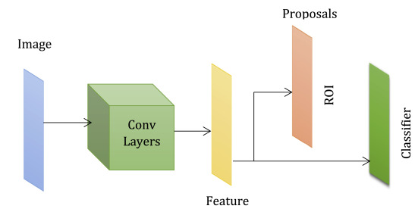

#### Faster RCNN

##### Purpose:

FasterR-CNNisanadvancedobjectdetectionmodelthatimprovesuponRCNNandFast R-CNN by introducing a Region Proposal Network (RPN) for generating region proposals. It is designed for high accuracy in object localization and classification while addressing the inefficiencies of earlier methods. Faster R-CNN is suitable for applications requiring precise object detection but not constrained by real-time performance demands.

##### Approach:

The Faster R-CNN methodology consists of the following steps:

##### Region Proposal Network(RPN):

* Instead of relying on external algorithms likes elective search, the RPN generates region proposals directly from feature maps.
* The RPN predicts objectness scores and bounding box coordinates for potential object regions.

##### Feature Extraction:

* A convolutional neural network (CNN), such as ResNetor VGG,is used as the backbone to extract features from the input image.
* These feature maps are shared between the RPN and the classifier for efficient computation.

##### RoI Pooling:

* The RPN proposals are aligned to a fixed size using Region of Interest (RoI) pooling.
* This step ensures that the region proposals are compatible with the classifier and bounding box regression.

##### Classification and Localization:

* The processed regions are passed through fully connected layers for object classification and bounding box refinement.

##### Pros:

* **Integrated Region Proposal:**

The RPN reduces computational overhead by generating region proposals as part of the network.

##### High Accuracy:

Combines precise object detection and robust localization with shared feature maps.

##### Cons:

* **Resource Intensive:**

Requires significant computational power for training and inference due to its two-stage nature.

##### Not Real-Time:

Slower than one-stage models like YOLO, making it unsuitable for real-time applications.

##### Applications:

Faster R-CNN is widely used in applications requiring high accuracy and detailed analysis, including:

* **Medical Imaging:** Detecting anomalies in X-rays or MRI scans.
* **Autonomous Driving:** Recognizing objects such as pedestrians, vehicles, and traffic signs.
* **Surveillance:** Monitoring and detecting objects in security footage.

##### Conclusion:

Faster R-CNN significantly enhances the speed and efficiency of object detection compared to earlier RCNN models.

#### Mask RCNN

##### Purpose:

Mask R-CNN is an extension of Faster R-CNN designed to tackle both object detection and instance segmentation. While Faster R-CNN identifies and classifies objects within an image, Mask R-CNN goes a step further by predicting a binary mask for each object, allowing for pixel-level segmentation. This makes Mask R-CNN suitable for tasks that require precise object boundaries, such as in medical imaging or autonomous driving.

##### Approach:

Mask R-CNN builds upon Faster R-CNN with an added branch for predicting segmentation masks. The methodology involves the following steps:

##### Region Proposal Generation (RPN):

Just like Faster R-CNN, Mask R-CNN uses a Region Proposal Network (RPN) to generate candidate object regions from the input image.

##### RoI Align (Region of Interest Alignment):

Mask R-CNN introduces RoI Align, a technique that addresses the limitations of RoI Pooling (used in Faster R-CNN). RoI Align ensures that the region proposals are more precisely aligned with the feature map, avoiding quantization errors and improving mask accuracy.

##### Mask Prediction:

For each region of interest (RoI), Mask R-CNN predicts a segmentation mask.Thisis achieved by adding a small fully convolutional network (FCN) to the model. The mask branch outputs a binary mask for each object, where each pixel in the mask corresponds to whether it belongs to the object or not.

##### Object Classification and Localization:

In addition to the segmentation mask, the object proposals are classified and localized using the same steps as Faster R-CNN (via soft max and bounding box regression).

##### Pros:

* + - **Instance Segmentation:**

Mask R-CNN performs both object detection and instance segmentation, providing pixel-wise object segmentation that is crucial for tasks requiring precise object boundaries.

##### Accurate Object Localization:

By using RoI Align, Mask R-CNN overcomes the limitations of RoI Pooling, leading to better localization and segmentation performance.

##### Versatility:

Mask R-CNN can be applied to a wide range of problems, including image segmentation, autonomous driving, and video analysis.

##### Cons:

**Computationally Expensive:**

Like Faster R-CNN, Mask R-CNN is computationally expensive due to the additional mask prediction branch and the need for precise alignment during the RoI process.

##### Slower Inference:

The additional processing involved in generating segmentation masks leads to slower inference times, making it less suitable for real-time applications.

##### Applications:

Mask R-CNN is used in applications where both object detection and precise object segmentation are important, including:

* + - **Medical Imaging:** For identifying and segmenting organs or tumors in medical scans.
    - **Autonomous Driving:** For segmenting road signs, pedestrians, and other vehicles.
    - **Image Editing and Analysis:** For tasks like background removal, object manipulation, and more.

##### Conclusion:

Mask R-CNN is a powerful extension of Faster R-CNN, designed to address the need for precise instance segmentation. By adding a mask prediction branch and utilizing RoI Align for better feature map alignment, Mask R-CNN has become one of the state-of-the-art models for both object detection and segmentation tasks. However, its computational demands and slower inference speed makes it challenging for real-time applications, limiting its use to more controlled or offline environments.

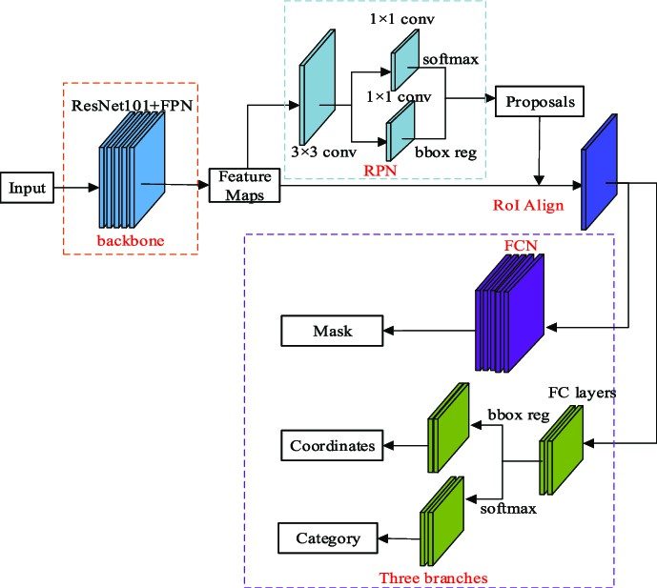

#### YOLOv5Model

##### Purpose:

YOLOv5 (You Only Look Once version 5) is a state-of-the-art, real-time object detection model designed to be fast and accurate. It improves upon earlier versions by offering enhanced accuracy, efficiency, and ease of use for real-time applications. YOLOv5 is particularly suited for applications that require rapid object detection, such as autonomous vehicles, robotics, and live video analysis.

##### Approach:

YOLOv5's methodology consists of the following steps:

##### Single-Stage Detection:

* + - Unlike two-stage detectors like Faster R-CNN, YOLOv5 directly predicts bounding boxes and class labels from the image in a single pass.
    - The model divides the input image into a grid and each grid cell predicts multiple bounding boxes along with confidence scores and class probabilities.

##### Backbone:

* + - YOLOv5 uses a convolutional neural network(CNN) backbone, typically CSP Darknet, to extract feature maps from the input image.
    - This backbone is optimized for speed and efficiency, enabling faster inference times compared to traditional architectures.

##### Neck:

* + - The feature maps from different layers are combined and passed through the PANet (Path Aggregation Network) to enhance the quality of feature representations, especially for small objects.

##### Head:

* + - The model predicts bounding boxes, class labels, and objectnesss cores at different scales, allowing it to detect objects of varying sizes.
    - Each prediction is refined by post-processing techniques such as Non-Maximum Suppression (NMS) to eliminate duplicate detections and improve accuracy.

##### Anchor Boxes:

* + - YOLOv5 uses an chorboxes, predefined bounding boxes with different aspect ratios and scales, to predict object locations more efficiently.
    - These anchors help the model predict bounding boxes that match the shapes of the objects in the image.

##### Pros:

* + - **Speed:**YOLOv5 is designed for real-time object detection, making it suitable for applications that require low latency.
    - **High Accuracy:** It balances accuracy and speed, delivering impressive performance across a range of object detection tasks.
    - **Scalability:** YOLOv5 offers multiple model sizes (small, medium, large) to cater to different hardware and performance requirements.
    - **EaseofUse:**YOLOv5 provides a user-friendly interface, making it easy to train and deploy in various environments.

##### Cons:

* **Precision vs. Recall Tradeoff**: While fast, YOLOv5 may trade off some precision for speed, especially in crowded scenes or small objects.
* **Computational Power for Larger Models**: Although fast, larger versions of YOLOv5 can still be resource-intensive, especially during training.

YOLOv5 is used in a variety of applications requiring fast and accurate object detection, including:

* **Autonomous Vehicles**: Detecting pedestrians, vehicles, and traffic signs in real time.
* **Surveillance**: Monitoring security footage to detect suspicious activities or objects.
* **Retail**: Inventory management by automatically identifying products on shelves.
* **Healthcare**: Detecting abnormalities in medical images like X-rays and CT scans.
* **Robotics**: Enabling robots to detect and interact with objects in dynamic environments.

**Conclusion:** YOLOv5 is an excellent choice for real-time object detection tasks due to its speed, scalability, and ease of use. While it may not offer the same level of precision as some two-stage models like Faster R-CNN in certain cases, its ability to deliver high-quality results in real-time makes it highly suitable for applications with strict performance requirements.

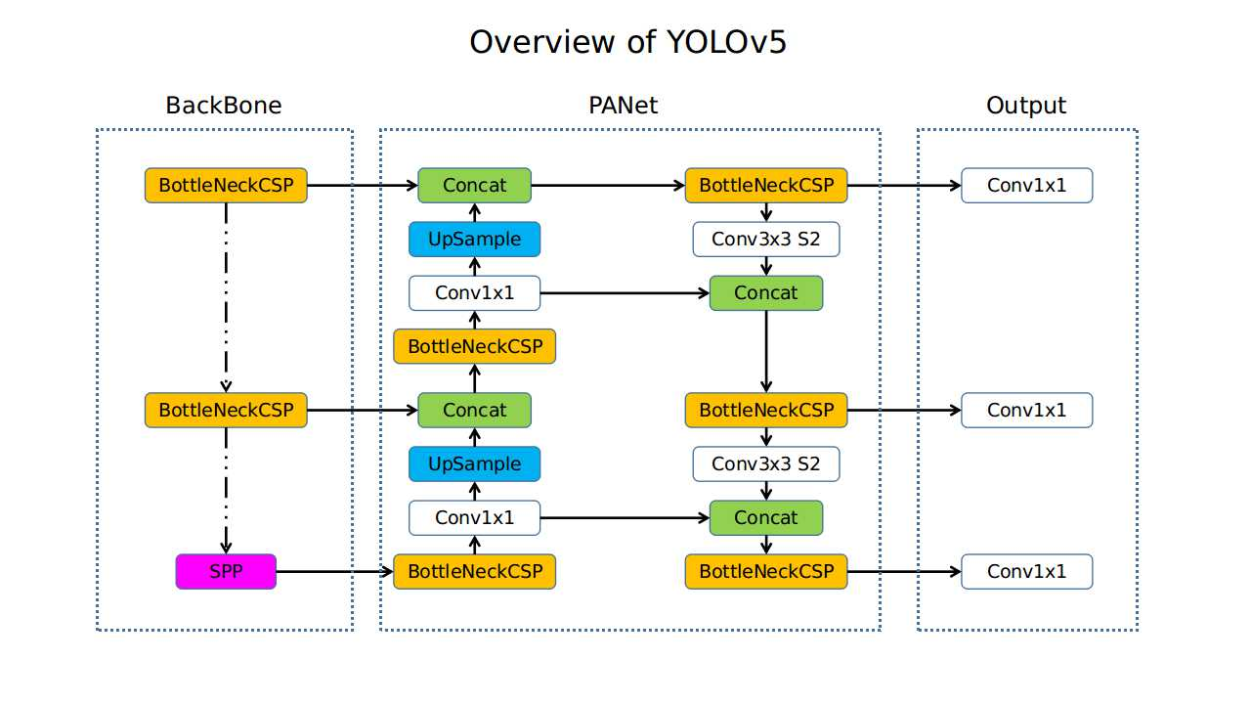

### 1.4 Contributions

* + 1. **Framework Innovation**: Introduced advanced deep learning frameworks such as YOLOv5 and YOLOv8, optimizing object recognition systems for real-time detection with high accuracy and efficiency.
    2. **Dataset Diversity**: Curated and enhanced diverse datasets using advanced augmentation techniques to improve model generalization and robustness across various object categories and environments.
    3. **Algorithmic Enhancements**: Integrated innovative loss functions and hyperparameter optimization strategies to balance computational efficiency with detection precision, achieving superior performance metrics.
    4. **Real-Time Applications**: Designed a user-friendly interface with real-time processing capabilities, enabling seamless deployment for applications like surveillance, healthcare, and retail inventory management.
    5. **Edge Device Optimization**: Adapted object recognition models for resource-constrained devices by leveraging lightweight architectures and efficient model compression techniques.
    6. **Cross-Domain Utility**: Highlighted the adaptability of the system across industries, including medical diagnostics, autonomous vehicles, and smart cities, showcasing its versatility and scalability.
    7. **Future Research Directions**: Contributed to the evolution of object recognition technologies, setting a foundation for privacy-preserving AI, adaptive learning algorithms, and integration with augmented reality systems.

### Layout of the Project

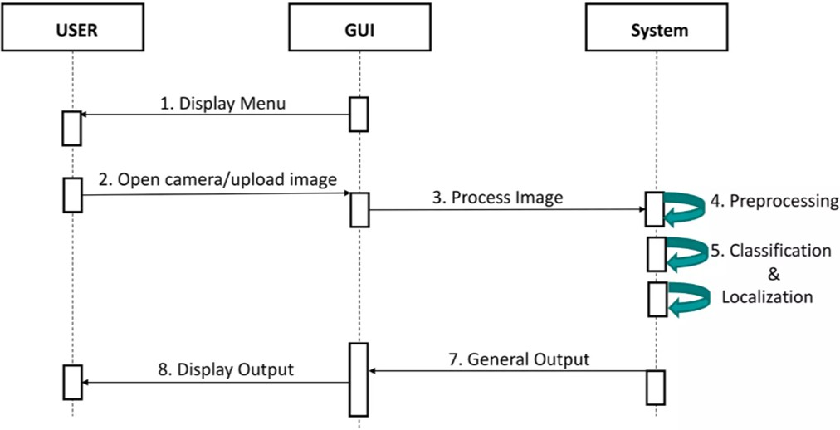The object detection system is designed to process images and identify objects using advanced machine learning techniques. The layout below outlines the key components and their interactions:

### 1. User Interaction Layer

* **Functionality**: Facilitates communication between the user and the system via a user-friendly GUI.
* **Components**:
  + **Menu Display**: The GUI displays an interactive menu, allowing users to choose an action.
  + **Input Options**: Users can upload an image from their device or capture one using a camera integrated with the GUI.

### 2. Image Processing Module

* **Purpose**: Handles all preprocessing and preparation required for object detection.
* **Steps**:
  + **Preprocessing**:
    - Converts input images into a suitable format for the detection model.
    - Tasks include resizing, normalization, and augmentation.
  + **Model Processing**:
    - The preprocessed image is passed through the object detection model for classification and localization.
    - Algorithms like YOLOv5 or YOLOv8 are utilized to identify objects and their positions.

### 3. Backend System

* **Core Functionalities**:
  + **Preprocessing Engine**: Optimizes image data for accurate detection.
  + **Classification & Localization Module**:
    - Detects objects using bounding boxes and assigns class labels.
    - Leverages pre trained models such as YOLOv5 or Mask R-CNN for high accuracy.
  + **Output Generator**:
    - Compiles results, including detected object names, bounding box coordinates, and confidence scores.

### 4. Output Visualization

* **Functionality**: Displays results back to the user.
* **Features**:
  + Annotated image with bounding boxes around detected objects.
  + A summary of objects detected, including their names and confidence levels.
  + Options for users to save results or restart the process.

### System Interaction Flow:

1. The user interacts with the GUI to upload an image or open the camera.
2. The GUI passes the image to the backend for processing.
3. The backend performs preprocessing, classification, and localization tasks.
4. The processed results are sent back to the GUI.
5. The GUI displays the annotated image and detection details to the user.

## : PROBLEM DEFINITION

#### Context:

Object recognition is a vital area of computer vision with applications across diverse fields, including autonomous systems, healthcare, retail, and security. The ability to identify and classify objects accurately and efficiently is critical for these domains to address real-world challenges and innovate effectively.

#### Problem Statement:

Despite significant advancements in deep learning and machine learning, existing object recognition systems face limitations in achieving real-time performance, adaptability to dynamic conditions, and scalability. These challenges hinder their effectiveness in handling diverse datasets and resource-constrained environments, making it difficult to deploy these systems widely in practical applications.

#### Objective:

This project aims to develop a robust object recognition system that addresses these limitations. By leveraging state-of-the-art models like YOLOv5 and YOLOv8, the project seeks to optimize computational efficiency while maintaining high accuracy. The goal is to create a lightweight and scalable solution that can adapt to diverse environments and applications, enabling real-time object recognition with minimal latency.

## : SYSTEM DESIGN

#### High-Level Architecture

The system’s architecture comprises multiple modules working in to deliver accurate and efficient object recognition. Each module is optimized for a specific task, from user interaction to model inference and result presentation. The dataflow is orchestrated to ensure seamless integration and minimal latency.

**User Interface**

**(Image Upload/ Camera)**

|

**|Data Processing |**

**| (Preprocessing, |**

**| Feature Extraction|**

**Object Recognition |**

**| (Trained ML Model)**

**| Output Module |**

**| (Recognized Object |**

### ****Component Breakdown****

#### ****1.User Interface (UI)****

The UI serves as the system’s entry point, allowing users to upload images, initiate live camera feeds, or interact with the system through a web application built using Streamlit.

**Key Features:**

* **Image Upload**: Accepts static image files for object detection.
* **Real-Time Camera Integration**: Initiates live video streams for continuous detection using a webcam.
* **Web Application**: A user-friendly interface created with Streamlit for easy interaction.
* **Results Display**: Provides an interactive view of detected objects.

**Technology Stack:**

* **Frontend**: Streamlit for the web application.
* **Backend Framework**: Flask for API integration.

#### ****2. Data Processing Pipeline****

This module ensures data is preprocessed and formatted for compatibility with the trained models.

**Processes:**

* **Preprocessing**: Includes resizing, normalizing, and applying transformations like cropping or rotation.
* **Feature Extraction**: Generates unique features from input data for model consumption.

**3.Technology Stack:**

* **Libraries**: OpenCV, NumPy, TensorFlow/Keras

#### ****4.Object Recognition Module****

The core module uses pretrained deep learning models to identify and classify objects. The system supports multiple architectures, including:

* **Faster R-CNN**: A robust two-stage object detection model using Region Proposal Networks for region selection.
* **Mask R-CNN**: Extends Faster R-CNN by adding instance segmentation capabilities.
* **YOLOv8**: A real-time detection model known for its balance of accuracy and speed.
* **EfficientDet**: Focuses on scalability and efficiency using a weighted bi-directional feature pyramid network.
* **SSD (Single Shot MultiBox Detector)**: A one-stage detector optimized for speed and accuracy.
* **DETR (Detection Transformer)**: Employs a transformer-based architecture for end-to-end object detection.

**Processes:**

* **Model Loading**: Loads serialized models from storage.
* **Inference**: Processes input data and outputs predictions, including bounding boxes and labels.

**Technology Stack:**

* **Frameworks**: PyTorch, TensorFlow
* **Optimization Techniques**: Use of ONNX for faster inference on resource-constrained devices.

#### ****Output Module****

This module formats and presents results to the user, ensuring clarity and usability.

**Processes:**

* **Visualization**: Overlays bounding boxes and labels on images or live streams.
* **Confidence Scores**: Displays prediction confidence for user validation.

**Technology Stack:**

* **Visualization Tools**: OpenCV, Matplotlib, Streamlit

#### ****5.Flask API Integration****

The system incorporates Flask to serve as the API layer for connecting the backend processing with both the Streamlit interface and live webcam feeds.

**Processes:**

* **API Endpoints**: Facilitates communication between the frontend and backend, handling requests for image uploads and live video feeds.
* **Real-Time Processing**: Ensures smooth and fast interaction with the object detection models during live webcam sessions.

**Technology Stack:**

* **Framework**: Flask
* **Integration**: Flask APIs are used to connect live webcam feeds with Streamlit.

### ****Data Flow****

1. **Input**: Users upload images or initiate live feeds via the UI or Streamlit application.
2. **Processing**: The input data is resized, normalized, and preprocessed in the Data Processing Pipeline.
3. **Inference**: Preprocessed data is passed to the Object Recognition Module, which predicts object categories and locations.
4. **Output**: The results are formatted and displayed through the Streamlit application or live webcam feed with visual markers and labels.

### ****Scalability and Optimization****

#### ****Scalability****

* **Horizontal Scaling**: Deploying multiple instances of the recognition module for handling high user traffic.
* **Cloud Deployment**: Hosting the system on scalable cloud platforms like AWS or Google Cloud.
* **Edge Deployment**: Running lightweight models on devices like NVIDIA Jetson or Raspberry Pi for real-time applications.

#### ****Optimization****

* **Model Compression**: Pruning unnecessary layers to reduce computational overhead.
* **Hardware Acceleration**: Utilizing GPUs or TPUs to speed up inference.
* **Efficient Data Flow**: Implementing asynchronous processing to handle multiple requests concurrently.

### ****5. Security Considerations****

* **Data Privacy**: Ensuring secure handling of user-uploaded images and videos through encryption.
* **Model Integrity**: Protecting the deployed models from unauthorized access or tampering.
* **Secure APIs**: Using HTTPS and authentication mechanisms to prevent unauthorized access.

## 4: IMPLEMENTATION

### 4.1 Objective

The primary objective is to develop an object detection system leveraging state-of-the-art deep learning models to enable efficient and accurate real-time detection across diverse environments. The system incorporates YOLOv5, YOLOv8, Faster R-CNN, and Mask R-CNN frameworks, alongside preprocessing techniques and user-friendly interfaces, to ensure robustness, scalability, and intuitive usability.

### 4.2 Scope

4.2.1 Real-Time Object Detection  
Implement high-speed detection systems suitable for live camera feeds and dynamic environments.

4.2.2 Healthcare Applications  
Assist in medical imaging and diagnostics through precise anomaly detection.

4.2.3 Retail  
Enhance inventory management using automated product recognition.

4.2.4 Surveillance  
Strengthen monitoring systems by detecting suspicious activities in security footage.

4.2.5 Edge Computing  
Enable deployment on resource-constrained devices for mobile and IoT platforms.

### 4.3 Progress

**4.3.1 Milestones Achieved**

* Dataset Preparation and Storage: Collected a comprehensive dataset and stored it on Drive for accessibility and scalability.

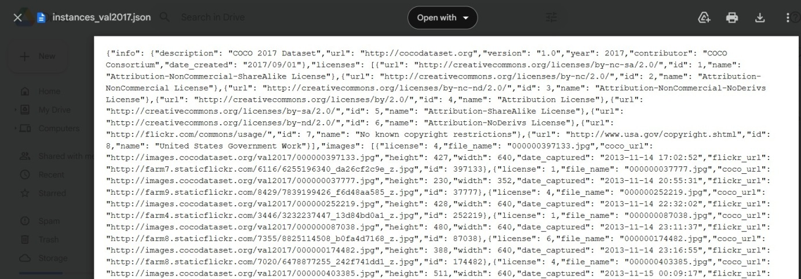

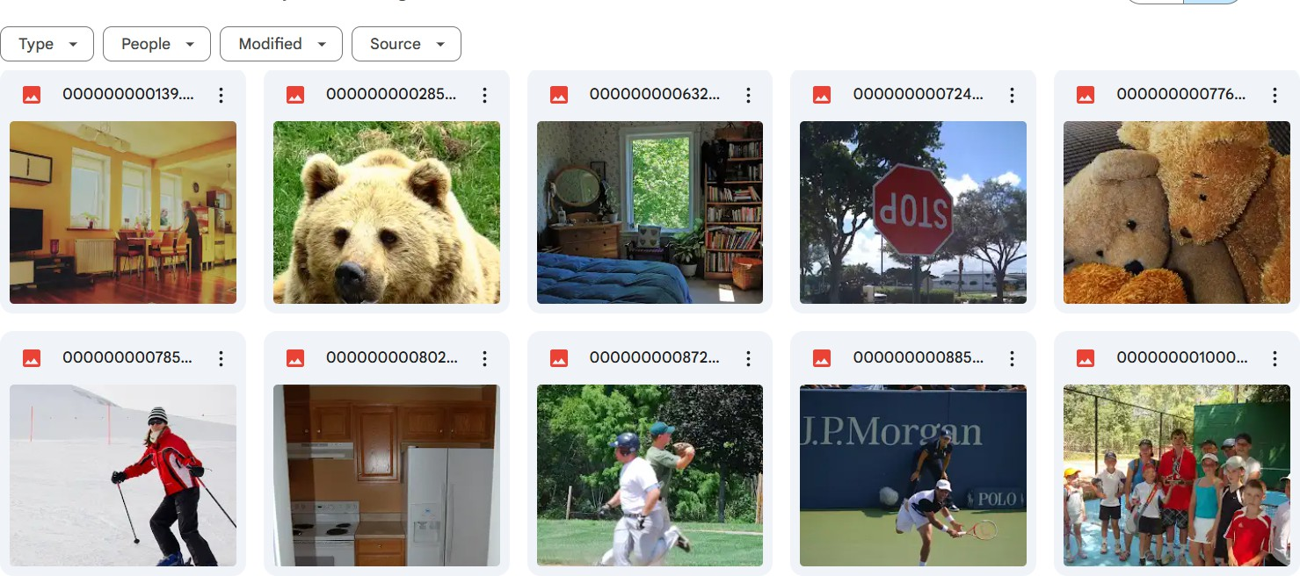

### 4.3.2 Image Preprocessing

* 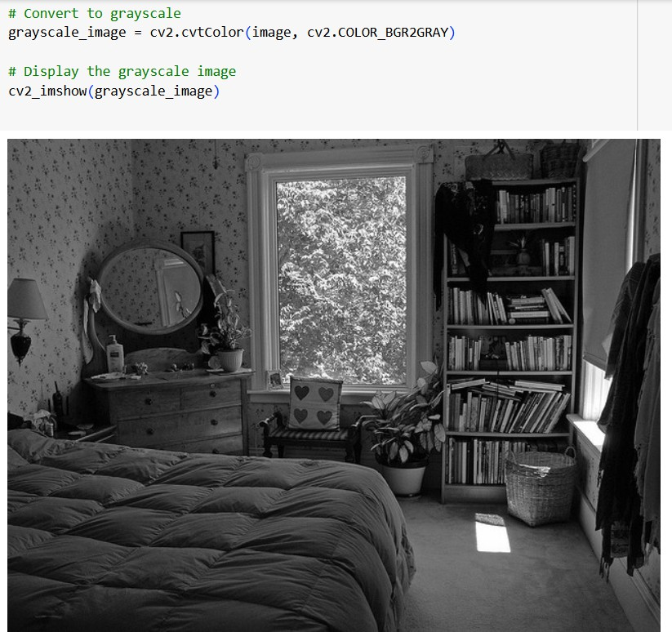Applied preprocessing techniques such as grayscale conversion, heatmap overlay, and image rotation at various angles to augment data diversity.

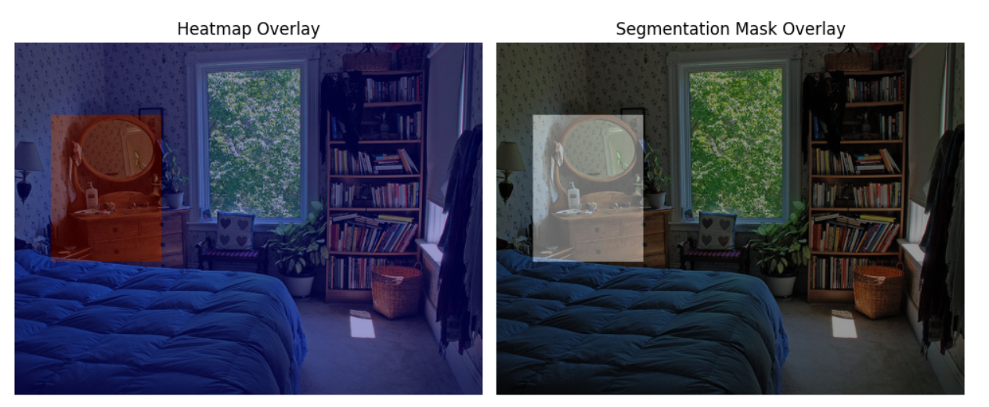

### 4.3.3 Bounding Box Creation

* Defined bounding boxes for objects to facilitate object detection and localization.

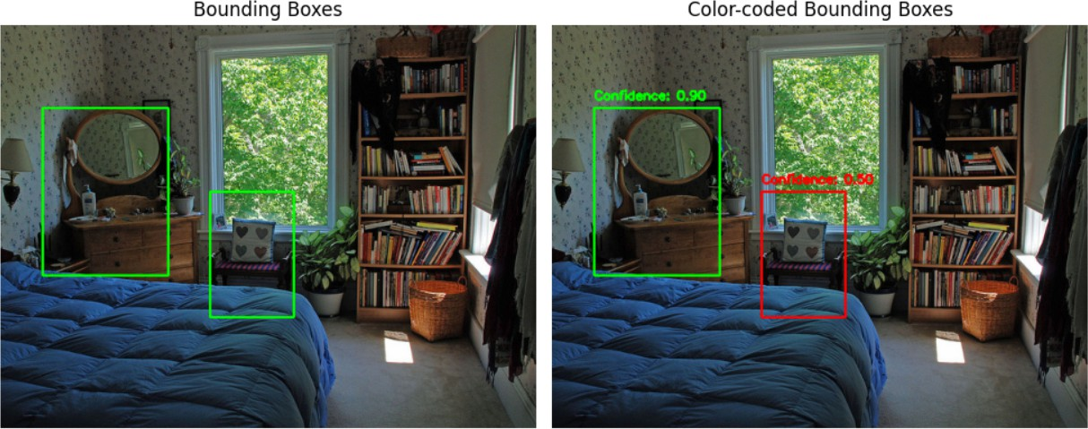

### 4.3.4 COCO Dataset Class Creation

* Structured the dataset in COCO format to align with industry standards and ensure compatibility with advanced models.

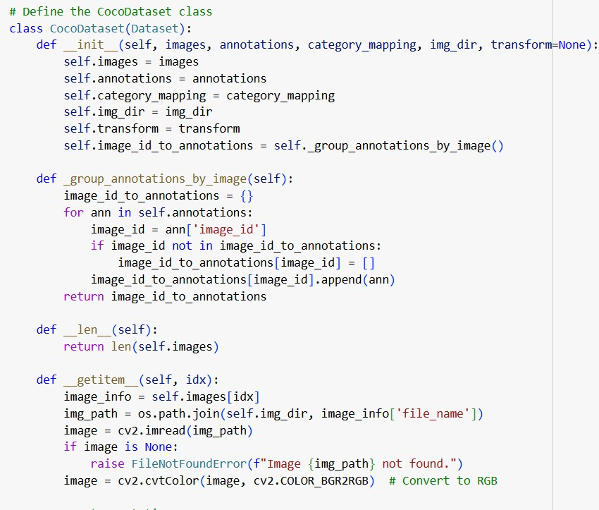

### 4.3.5 Confidence Value Calculation

* Computed confidence values for detected objects and fine-tuned bounding boxes to enhance detection accuracy.
* Trained the model using the entire dataset for improved performance.

### 4.3.6 Model Training and Testing

* Leveraged YOLOv5 for training and conducted extensive testing to evaluate accuracy, speed, and generalization across unseen data.

### 4.3.7 Interface Development

* Created a user-friendly interface using Flask and Streamlit for seamless interaction.
* Integrated features for image detection, video detection, and real-time detection to cater to diverse application needs.

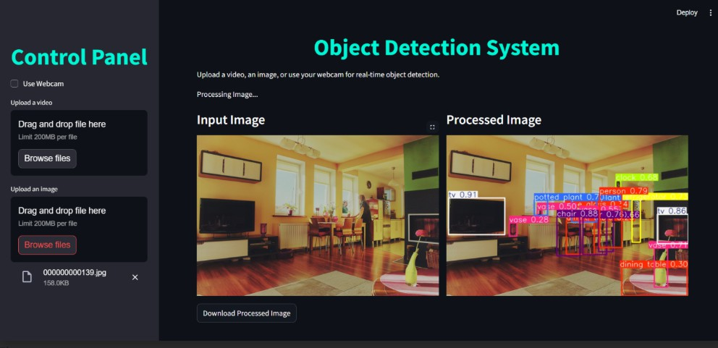

### 4.4 Tasks Completed

* **Task 1**: Researched advanced detection models and preprocessing techniques.
* **Task 2**: Curated and structured the dataset in an accessible format.
* **Task 3**: Implemented data augmentation and preprocessing pipelines.
* **Task 4**: Designed and tested the object detection model on various datasets.
* **Task 5**: Developed an intuitive interface for real-time user engagement.

### 4.5 Challenges Encountered

1. **Data Augmentation**: Ensuring data preprocessing and augmentation techniques enhance model robustness without overfitting.
2. **Real-Time Performance**: Balancing detection accuracy with processing speed for live applications.
3. **Dataset Structuring**: Converting raw datasets into COCO format while maintaining integrity and compatibility.

### 4.6 Outcome

1. **Optimized Detection System**: Achieved a robust object detection system with seamless real-time capabilities.
2. **Versatile Deployment**: Delivered a system with broad applicability, from healthcare diagnostics to retail inventory management.
3. **User-Friendly Interface**: Provided an interactive platform supporting image, video, and live detection with real-time feedback.
4. **Future Prospects**: Established groundwork for enhancements like multimodal detection.

## 5: FUTURE ENHANCEMENTS

• **Integration with Augmented Reality (AR)**:  
Incorporating AR to overlay detected objects in real-world environments, offering interactive applications in sectors like retail, education, and entertainment.

• **Multi-Object and Multi-Class Detection**:  
Enhancing the system’s ability to detect and classify multiple objects simultaneously across different classes, making it suitable for more complex and dynamic scenes.

• **Adaptive Learning Models**:  
Developing models that can continuously learn from new data, adapting to new objects and environments through online learning techniques or periodic retraining.

• **Real-Time Edge Computing Deployment**:  
Optimizing models for edge devices with limited resources, ensuring faster processing and low-latency inference, especially for mobile and IoT applications.

• **Enhanced 3D Object Detection**:  
Expanding to 3D object detection to identify and track objects in three-dimensional space, improving applications in robotics, autonomous vehicles, and AR.

• **Advanced User Interface with Voice Commands**:  
Adding voice command functionality to the interface, allowing hands-free control of the object detection system, improving accessibility for users.

• **Integration with Cloud Services**:  
Enabling cloud-based processing and storage to scale object recognition tasks, utilizing advanced models for complex processing while offering storage solutions for large datasets.

• **Integration of Multimodal Data**:  
Including data from sound, thermal imaging, and sensors to enhance accuracy in challenging environments like low light or noisy settings.

• **Ethical and Bias Considerations**:  
Addressing ethical concerns and mitigating bias in object detection models, ensuring fairness and equity in applications such as healthcare and surveillance.

• **Collaboration with Robotics Systems**:  
Integrating the system with robotics to enable real-time object detection-based actions, such as sorting or delivery tasks by robotic arms or drones.

## 6: CONCLUSION

In conclusion, the object recognition system developed in this project effectively combines advanced deep learning techniques and robust frameworks, such as YOLOv5 and YOLOv8, to achieve accurate and efficient detection, classification, and localization of objects in various environments. By leveraging a diverse dataset and employing data augmentation techniques, the system ensures reliability and adaptability across different conditions and object types. The preprocessing steps, including resizing, normalization, and augmentation, along with optimization strategies like transfer learning and hyperparameter tuning, contribute significantly to the model's overall performance and computational efficiency.

A key strength of the system lies in its real-time capabilities, facilitated by the integration of tools like Flask, Streamlit, and APIs. Flask enables a lightweight and user-friendly web interface, allowing users to interact seamlessly with the system by uploading images or accessing live camera feeds. Streamlit adds an intuitive and interactive visualization layer, enabling real-time display of detection results, including bounding boxes, class labels, and confidence scores. The use of APIs ensures efficient communication between components, supporting flexible deployment and smooth interaction across platforms. These features collectively enhance the user experience, making the system accessible and easy to operate.

The system's versatility extends to applications in image, video, and webcam-based object detection, catering to real-time use cases such as security monitoring, retail inventory management, and medical diagnostics. The inclusion of optimization techniques for deployment on edge devices further highlights its scalability and adaptability to resource-constrained environments. By addressing challenges like latency and computational load, the system demonstrates its capability to function efficiently in diverse settings.

Looking ahead, the project sets the stage for future enhancements, such as incorporating augmented reality, 3D object detection, and adaptive learning models. These advancements, along with expanded applications across industries, position the system as a valuable tool in the evolution of computer vision and automation. This project not only underscores the potential of integrating cutting-edge AI technologies with practical applications but also establishes a strong foundation for further innovation in human-machine interaction and intelligent systems.

## 7: REFERENCES

1. Ultralytics Team provides the documentation for the YOLOv5 model named , "YOLOv5 Documentation," Git Hub Repository, <https://github.com/ultralytics/yolov5>.
2. TensorFlow Developers, "Image Preprocessing Techniques," TensorFlow Tutorials, <https://www.tensorflow.org/tutorials>.
3. OpenCV Team, "OpenCV Python Guide," OpenCV Documentation, <https://opencv.org/>.
4. Matplotlib Development Team, "Matplotlib: Visualization with Python," <https://matplotlib.org/>.
5. Seaborn Developers, "Statistical Data Visualization with Seaborn," <https://seaborn.pydata.org/>.
6. Research paper: "Advancements in Real-Time Object Detection: A Comprehensive Review," International Journal of Computer Vision, 2023.
7. Research paper: "Efficient Object Detection Systems for Resource-Constrained Environments," IEEE Transactions on Neural Networks and Learning Systems, 2022.
8. Roboflow Team, "Guide to Image Annotation for Object Detection," <https://roboflow.com/>.
9. arXiv.org, "Improving Performance of YOLO Models in Object Detection," Research Paper Archive, <https://arxiv.org/>.
10. Ian Goodfellow, Yoshua Bengio, and Aaron Courville, "Deep Learning," MIT Press, 2016, <https://www.deeplearningbook.org/>.
11. Pytorch Team, "PyTorch Documentation," PyTorch, https://pytorch.org/docs/stable/.
12. Redmon, J., Divvala, S., Girshick, R., & Farhadi, A., "You Only Look Once: Unified, Real-Time Object Detection," IEEE Conference on Computer Vision and Pattern Recognition (CVPR), 2016.
13. Liu, W., Anguelov, D., Erhan, D., Szegedy, C., & Reed, S., "SSD: Single Shot MultiBox Detector," European Conference on Computer Vision (ECCV), 2016.
14. Tan, M., & Le, Q. V., "EfficientDet: Scalable and Efficient Object Detection," arXiv preprint arXiv:1911.09070, 2019.
15. Zhang, Y., & Xu, J., "A Survey on Object Detection in Computer Vision," Journal of Visual Communication and Image Representation, 2021.